PRO-C168

CUSTOM MARKER AR

What did we ACHIEVE in the class TODAY?

● Learned about pattern marker augmented reality webapps.

● Learned to create a basic web based AR app using patternmarkers.

● Learned to create pattern markers.

Which CONCEPTS/CODING BLOCKS did we cover today?

● AR.js marker creating tool.

● <a-marker>,<a-entity> , <a-assets> tags

● ngrok to run the application.

1. OpenAR.jsmarkercreatingtoolanduploadthe imagetodownloadthemarker in the.patt file format

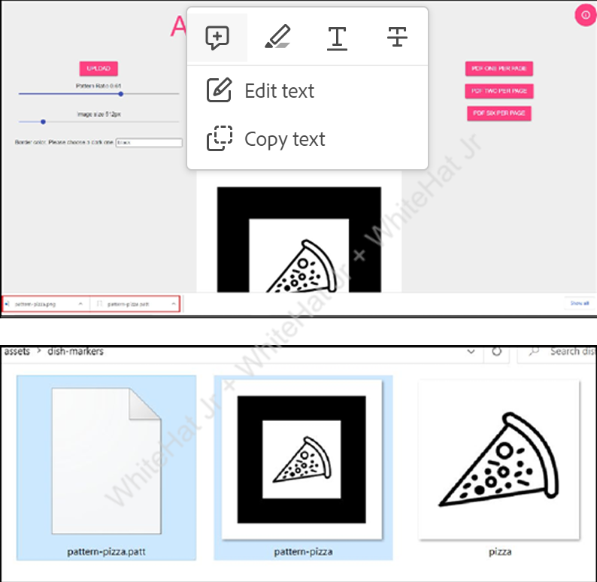

1. Add the pizza model asset using <a-assets>.

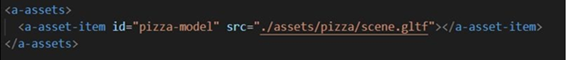

1. Set <a-marker> properties, the pizza model entity and the text entities for the name of the dish with ingredients as the child entity.

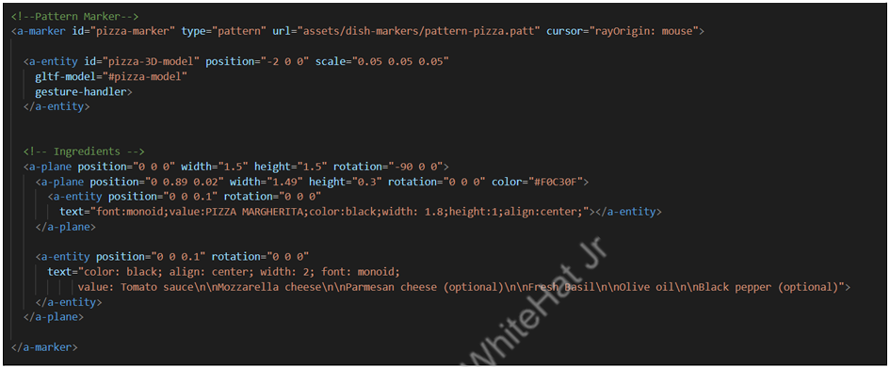

1. Add buttons to allow the user to order and rate the project.

● Add div element.

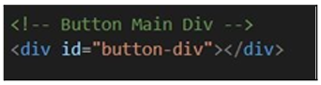

● Register the “create-buttons” component.

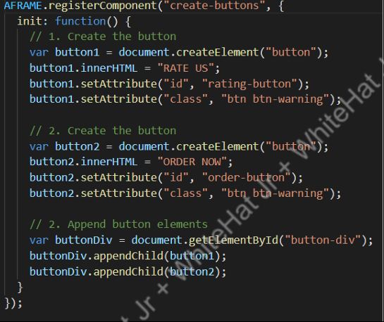

● Add the src and attach it to the <a-scene> elementin the index.html

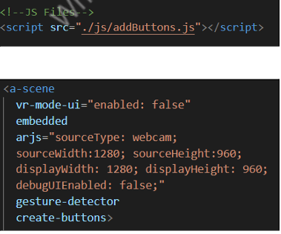

1. Create a .css file and add the styling to the button element.

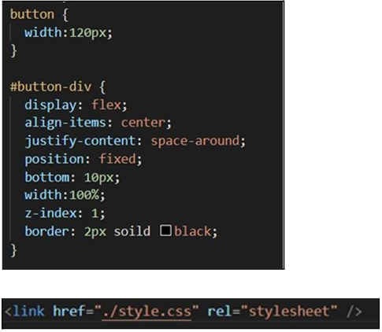

1. Run and test the application using the https ngrokURL.

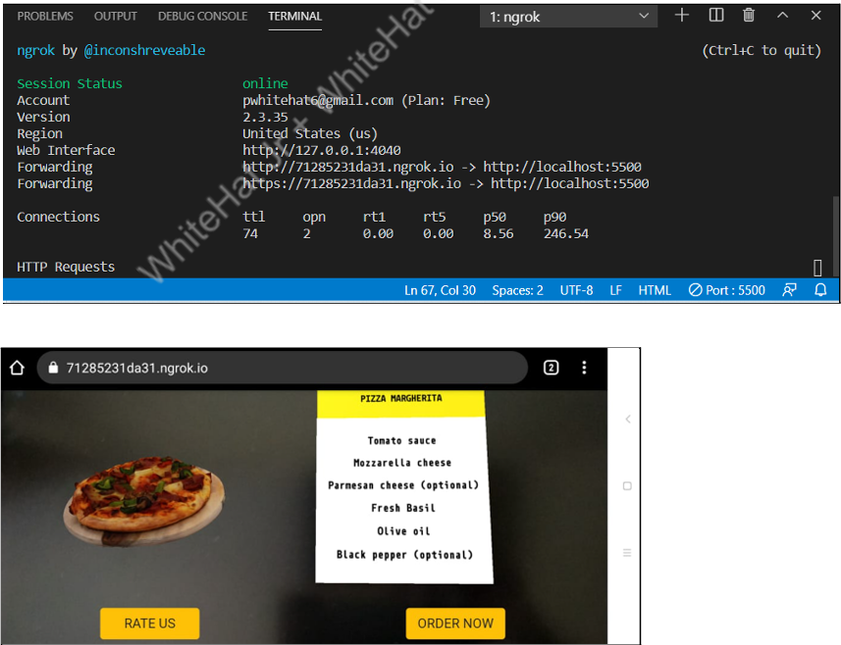

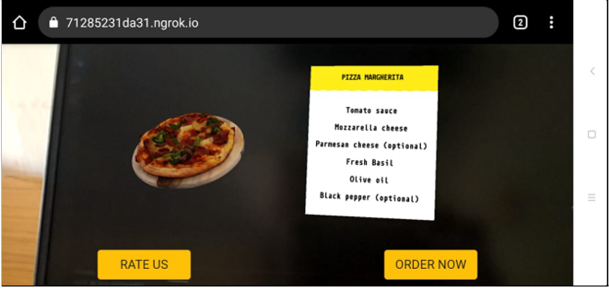

We have successfully created the pattern marker usinga pizza image and displayed content over that.

EXTEND YOUR KNOWLEDGE:

● You can refer to the link below to explore more aboutA-Frame: A-Frame

● You can refer to the link below to explore more aboutAR.js: AR.js